SIMATS ENGINEERING
ASSESSMENT TOOL 1 - Short Answer Test

COURSE NAME: COMPUTER VISION COURSE CODE: ITA05
COURSE OUTCOME COVERED
CO1: Apply the fundamental concepts, image formation models, and processing techniques for analyzing Computer Vision systems. (BTL 3)
Assessment Tool Weightage: 40%
QUESTIONS
1. A digital camera produces banding effects. Write a Python program to demonstrate image banding.
2. A thermal imaging system captures temperature information. Write a Python program to process a thermal image.
3. A blurred image is obtained due to motion. Write a Python program to simulate motion blur.

Code of Conduct:
I K. Vijay Bhaskar Reddy(192425155) certify that this submission is my original work and that I have adhered to the guidelines specified for this assessment.
I understand that any violation of academic integrity rules will result in disciplinary action.
Signature of the student:
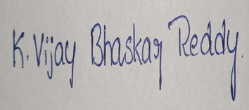

1. A digital camera produces banding effects. Write a Python program to demonstrate image banding. 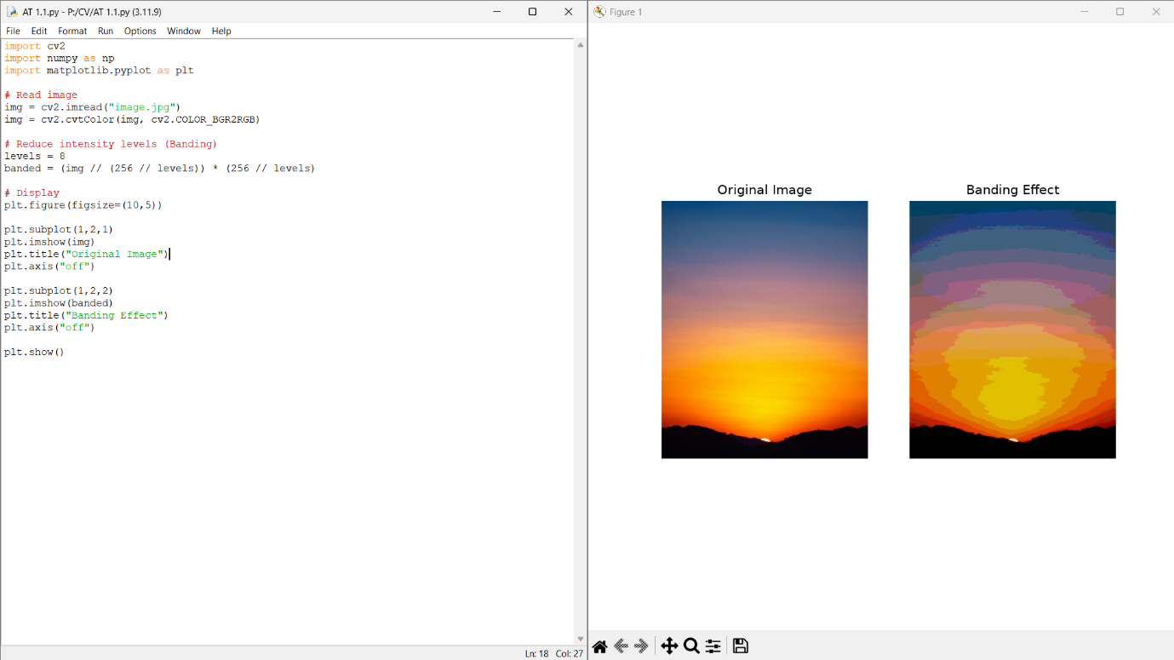

2. A thermal imaging system captures temperature information. Write a Python program to process a thermal image.
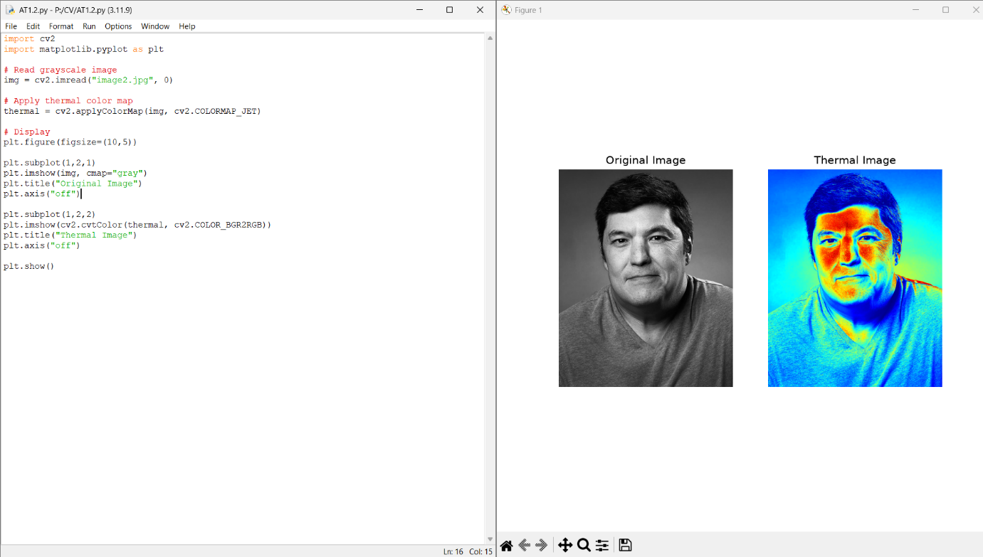

3. A blurred image is obtained due to motion. Write a Python program to simulate motion blur.
